**Inter-VLAN Communication**

Student Version



Huawei Technologies Co., Ltd.

|  |
| --- |
| **Copyright © Huawei Technologies Co., Ltd. 2020. All rights reserved.**  No part of this document may be reproduced or transmitted in any form or by any means without prior written consent of Huawei Technologies Co., Ltd.  **Trademarks and Permissions**  HW_POS_RBG_Vertical-150ppi.png and other Huawei trademarks are trademarks of Huawei Technologies Co., Ltd.  All other trademarks and trade names mentioned in this document are the property of their respective holders.  **Notice**  The purchased products, services and features are stipulated by the contract made between Huawei and the customer. All or part of the products, services and features described in this document may not be within the purchase scope or the usage scope. Unless otherwise specified in the contract, all statements, information, and recommendations in this document are provided "AS IS" without warranties, guarantees or representations of any kind, either express or implied.  The information in this document is subject to change without notice. Every effort has been made in the preparation of this document to ensure accuracy of the contents, but all statements, information, and recommendations in this document do not constitute a warranty of any kind, express or implied. |

|  |  |
| --- | --- |
| Huawei Technologies Co., Ltd. | |
| Address: | Huawei Industrial Base  Bantian, Longgang  Shenzhen 518129  People's Republic of China |
| Website: | <https://e.huawei.com/> |

**Huawei Certification System**

Huawei Certification follows the "platform + ecosystem" development strategy, which is a new collaborative architecture of ICT infrastructure based on "Cloud-Pipe-Terminal". Huawei has set up a complete certification system consisting of three categories: ICT infrastructure certification, platform and service certification, and ICT vertical certification. It is the only certification system that covers all ICT technical fields in the industry. Huawei offers three levels of certification: Huawei Certified ICT Associate (HCIA), Huawei Certified ICT Professional (HCIP), and Huawei Certified ICT Expert (HCIE). Huawei Certification covers all ICT fields and adapts to the industry trend of ICT convergence. With its leading talent development system and certification standards, it is committed to fostering new ICT talent in the digital era, and building a sound ICT talent ecosystem.

Huawei Certified ICT Associate-Datacom (HCIA-Datacom) is designed for Huawei's frontline engineers and anyone who want to understand Huawei's datacom products and technologies. The HCIA-Datacom certification covers routing and switching principles, basic WLAN principles, network security basics, network management and O&M basics, SDN and programmability and automation basics.

The Huawei certification system introduces the industry, fosters innovation, and imparts cutting-edge datacom knowledge.

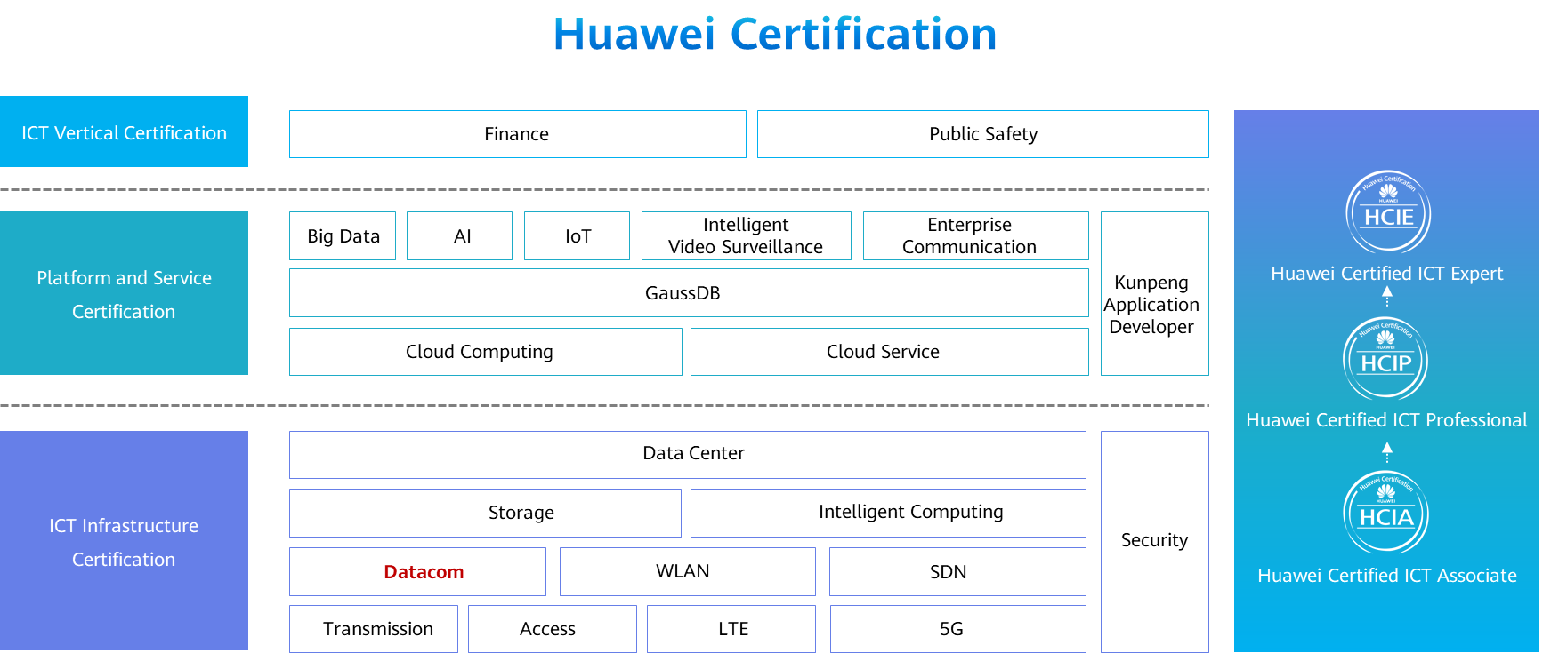

# Inter-VLAN Communication

## Background

VLANs are separated at Layer 2 to minimize broadcast domains. To enable the communication between VLANs,Huawei provides a variety of technologies. The following two technologies are commonly used:

Dot1q termination sub-interface: Such sub-interfaces are Layer 3 logical interfaces. Similar to a VLANIF interface, after a dot1q termination sub-interface and its IP address are configured, the device adds the corresponding MAC address entry and sets the Layer 3 forwarding flag to implement Layer 3 communication between VLANs. A Dot1q termination sub-interface applies to scenarios where a Layer 3 Ethernet port connects to multiple VLANs.

VLANIF interface: VLANIF interfaces are Layer 3 logical interfaces. After a VLANIF interface and its IP address are configured, the device adds the MAC address and VID of the VLANIF interface to the MAC address table and sets the Layer 3 forwarding flag of the MAC address entry. When the destination MAC address of a packet matches the entry, the packet is forwarded at Layer 3 to implement Layer 3 communication between VLANs.

In this lab activity, you will use two methods to implement inter-VLAN communication.

## Objectives

Upon completion of this task, you will be able to:

Learn how to use Dot1q termination sub-interfaces to implement inter-VLAN communication

Learn how to use VLANIF interfaces to implement inter-VLAN communication

Understand the forwarding process of inter-VLAN communication

## Topology

Lab Topology

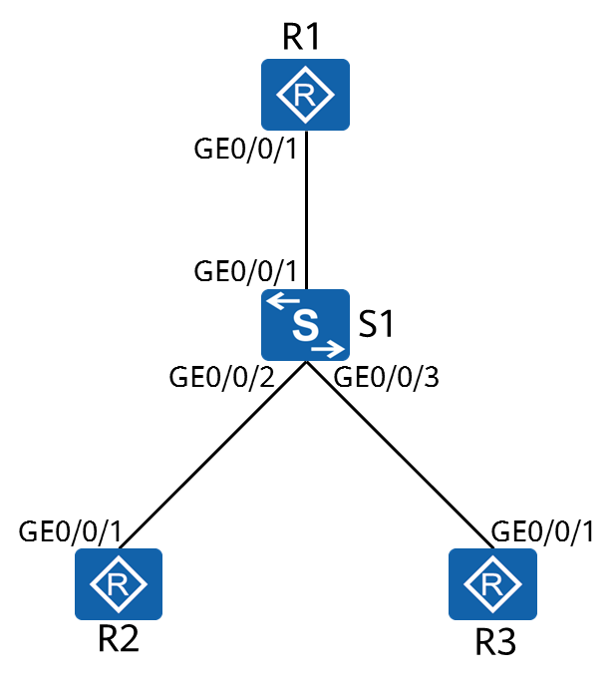

R2 and R3 belong to different VLANs and they need to communicate with each other through VLANIF interfaces and Dot1q termination sub-interfaces.

1. Simulate terminal users on R2 and R3 and assign IP addresses 192.168.2.1/24 and 192.168.3.1/24 to the interfaces.
2. The gateway addresses of R2 and R3 are 192.168.2.254 and 192.168.3.254 respectively.
3. On S1, assign GigabitEthernet0/0/2 and GigabitEthernet0/0/3 to VLAN 2 and VLAN 3, respectively.

## Implementation

### Roadmap

1. Configure Dot1q termination sub-interfaces to implement inter-VLAN communication.
2. Configure VLANIF interfaces to implement inter-VLAN communication.

### Procedure

Complete basic device configuration.

# Name R1, R2, R3, and S1.

The details are not provided here.

# Configure IP addresses and gateways for R2 and R3.

<R2>

*Configure a default route (equivalent to a gateway) for the device.*

<R3>

# On S1, assign R2 and R3 to different VLANs.

[S1]

Configure Dot1q termination sub-interfaces to implement INter-VLAN communication.

# Configure a trunk port on S1.

[S1]

# Configure a dot1q termination sub-interface on R1.

[R1]

A sub-interface is created and the sub-interface view is displayed. In this example, **2** indicates the sub-interface number. It is recommended that the sub-interface number be the same as the VLAN ID.

[R1-GigabitEthernet0/0/1.2]

The **dot1q termination vid** *vlan-id* command configures the VLAN ID for Dot1q termination on a sub-interface.

In this example, when GigabitEthernet0/0/1 receives data tagged with VLAN 2, it sends the data to sub-interface 2 for VLAN termination and subsequent processing. The data sent from sub-interface 2 is also tagged with VLAN 2.

[R1-GigabitEthernet0/0/1.2]

Sub-interfaces for VLAN tag termination cannot forward broadcast packets and automatically discard them upon receiving. To allow such sub-interfaces to forward broadcast packets, the ARP broadcast function must be enabled using the **arp broadcast enable** command. By default, this function is enabled on some devices.

[R1]

# Test the connectivity between VLANs.

<R2>ping 192.168.3.1

PING 192.168.3.1: 56 data bytes, press CTRL\_C to break

Reply from 192.168.3.1: bytes=56 Sequence=1 ttl=254 time=60 ms

Reply from 192.168.3.1: bytes=56 Sequence=2 ttl=254 time=40 ms

Reply from 192.168.3.1: bytes=56 Sequence=3 ttl=254 time=110 ms

Reply from 192.168.3.1: bytes=56 Sequence=4 ttl=254 time=70 ms

Reply from 192.168.3.1: bytes=56 Sequence=5 ttl=254 time=100 ms

--- 192.168.3.1 ping statistics ---

5 packet(s) transmitted

5 packet(s) received

0.00% packet loss

round-trip min/avg/max = 40/76/110 ms

<R2>tracert 192.168.3.1

traceroute to 192.168.3.1(192.168.3.1), max hops: 30 ,packet length: 40,press CTRL\_C to break

1 192.168.2.254 30 ms 50 ms 50 ms

2 192.168.3.1 70 ms 60 ms 60 ms

VLAN 2 and VLAN 3 can communicate with each other.

Configure VLANIF interfaces to enable inter-VLAN communication.

# Delete the configuration in the previous step.

[S1]

# Create a VLANIF interface on S1.

[S1]interface Vlanif 2

The **interface vlanif** *vlan-id* command creates a VLANIF interface and displays the VLANIF interface view. You must create a VLAN before configuring a VLANIF interface.

[S1]

# Test the connectivity between VLANs.

<R2>ping 192.168.3.1

PING 192.168.3.1: 56 data bytes, press CTRL\_C to break

Reply from 192.168.3.1: bytes=56 Sequence=1 ttl=254 time=100 ms

Reply from 192.168.3.1: bytes=56 Sequence=2 ttl=254 time=50 ms

Reply from 192.168.3.1: bytes=56 Sequence=3 ttl=254 time=50 ms

Reply from 192.168.3.1: bytes=56 Sequence=4 ttl=254 time=60 ms

Reply from 192.168.3.1: bytes=56 Sequence=5 ttl=254 time=70 ms

--- 192.168.3.1 ping statistics ---

5 packet(s) transmitted

5 packet(s) received

0.00% packet loss

round-trip min/avg/max = 50/66/100 ms

<R2>tracert 192.168.3.1

traceroute to 192.168.3.1(192.168.3.1), max hops: 30 ,packet length: 40,press CTRL\_C to break

1 192.168.2.254 40 ms 30 ms 20 ms

2 192.168.3.1 40 ms 30 ms 40 ms

VLAN 2 and VLAN 3 can communicate with each other.

**----End**

* 1. **Verification**

The details are not provided here.